Search vehicle information, such as checking the rental activity of our unit at foreign locations using Wizard, finding open/closed contracts etc.

B313 – How to Lookup Vehicle by MVA

Mandatory Fields:

ACTION: DS
MVA NO: MVA number with no dashes/spaces in between

Press Enter.

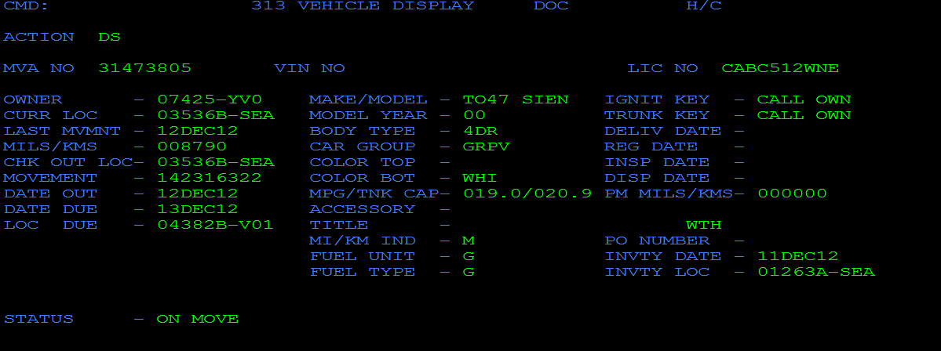

This screen displays the most current vehicle information and activity. If a contract is opened for the unit, its RA Number can be found in the Movement field.

With the RA Number, we can pull the open contract from B203. The B203 is equivalent to the Contract Changes screen in GIS. It will only allow retrieval of open contracts. Closed contracts are retrieved in B806, which is the GIS equivalent of Contract Check In.

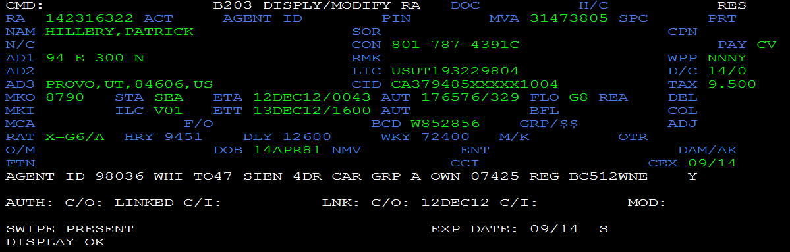
B314 – How to Lookup Vehicle by License Plate

Mandatory Fields:

ACTION: DS
LIC NO: (For Brac BC units only) CABC + license plate number
(For foreign US units) license plate number
DATE: Date (e.g. 12DEC12)
TIME: Time (time is in 24hr format - e.g. 1000)

Note that no information is returned if the date and time entered are not within a rental period. In the example below, if a contract is rented from Dec 12, 2012 00:43 to Dec 13, 2012 16:00, the date and time entered must be within this rental period in order to pull out the correct vehicle and contract information.

Press Enter.

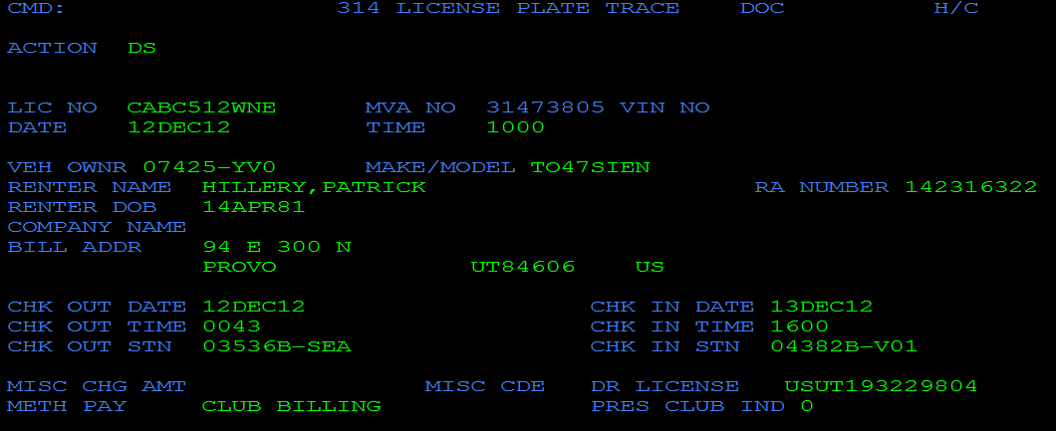

With the RA Number, we can pull the open contract from B203.

